**Task 1**

**Neural Network and Deep Learning**

**Team ID: SC_H17**

|  |  |
| --- | --- |
| **ID** | **Name** |
| 20191700785 | يوسف محمد جمعه محمد |
| 20191700606 | محمود محمد احمد عمران |
| 20191700620 | مروان محمد عبد الحليم السيد |
| 20191700460 | كيرلس نبيل منير فهمي |
| 20191700274 | ساره عادل الجبالي محمد |

1. **Feature X1 with other features:**

|  |  |
| --- | --- |
| **X1 & X2**  Adelie & Chinstrap $→$**Good** Discrimination  Adelie & Gentoo $→$**Good** Discrimination  Chinstrap & Gentoo $→$**Bad** Discrimination | **X1 & X3**  Adelie & Chinstrap $→$**Bad** Discrimination  Adelie & Gentoo $→$**Bad** Discrimination  Chinstrap & Gentoo $→$**Good** Discrimination |
| **X1 & X4**  Adelie & Chinstrap $→$**Bad** Discrimination  Adelie & Gentoo $→$**Bad** Discrimination  Chinstrap & Gentoo $→$**Bad** Discrimination | **X1 & X5**  Adelie & Chinstrap $→$**Bad** Discrimination  Adelie & Gentoo $→$**Bad** Discrimination  Chinstrap & Gentoo $→$**Good** Discrimination |

**The best combination of features: X1 & X2**

1. **Feature X2 with other features:**

|  |  |
| --- | --- |
| **X2 & X3**  Adelie & Chinstrap $→$**Bad** Discrimination  Adelie & Gentoo $→$**Good** Discrimination  Chinstrap & Gentoo $→$**Good** Discrimination | **X2 & X4**  Adelie & Chinstrap $→$**Bad** Discrimination  Adelie & Gentoo $→$**Bad** Discrimination  Chinstrap & Gentoo $→$**Good** Discrimination |
| **X2 & X5**  Adelie & Chinstrap $→$**Bad** Discrimination  Adelie & Gentoo $→$**Good** Discrimination  Chinstrap & Gentoo $→$**Good** Discrimination |

**The best combination of features: X2 & X3**

1. **Feature X3 with other features:**

|  |  |
| --- | --- |
| **X3 & X4**  Adelie & Chinstrap $→$**Bad** Discrimination  Adelie & Gentoo $→$**Bad** Discrimination  Chinstrap & Gentoo $→$**Good** Discrimination | **X3 & X5**  Adelie & Chinstrap $→$**Bad** Discrimination  Adelie & Gentoo $→$**Bad** Discrimination  Chinstrap & Gentoo $→$**Bad** Discrimination |

**The best combination of features: X3 & X4**

1. **Feature X4 with other features:**

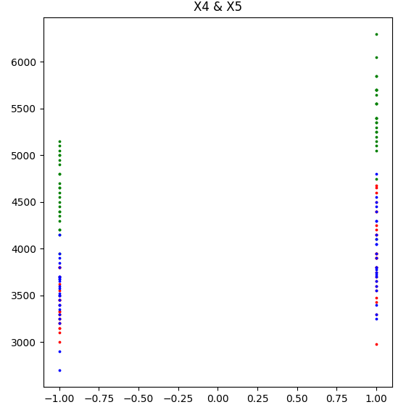

|  |
| --- |
| **X4 & X5**  Adelie & Chinstrap $→$**Bad** Discrimination  Adelie & Gentoo $→$**Good** Discrimination  Chinstrap & Gentoo $→$**Good** Discrimination |

* **30 Combinations of 2 features for 2 classes**

|  |  |
| --- | --- |
| 1. **X1 & X2 (Adelie - Gentoo), Acc = 100%**    | 1. **X1 & X2 (Adelie - Chinstrap), Acc = 100%**    |
| 1. **X1 & X2 (Gentoo - Chinstrap), Acc = 97.5%**    | 1. **X1 & X3 (Adelie - Gentoo), Accuracy = 65%**    |
| 1. **X1 & X3 (Adelie - Chinstrap), Acc = 90%**    | 1. **X1 & X3 (Gentoo - Chinstrap), Acc = 95%**    |

|  |  |
| --- | --- |
| 1. **X1 & X4 (Adelie - Gentoo), Acc = 75.5%**    | 1. **X1 & X4 (Adelie - Chinstrap), Acc = 50%**    |
| 1. **X1 & X4 (Gentoo - Chinstrap), Acc = 50%**    | 1. **X1 & X5 (Adelie - Gentoo), Acc = 50%**    |
| 1. **X1 & X5 (Adelie - Chinstrap), Acc = 50%**    | 1. **X1 & X5 (Gentoo - Chinstrap), Acc = 97.5%**    |

|  |  |
| --- | --- |
| 1. **X2 & X3 (Adelie - Gentoo), Acc = 100%**    | 1. **X2 & X3 (Adelie - Chinstrap), Acc = 65%**    |
| 1. **X2 & X3 (Gentoo - Chinstrap), Acc = 100%**    | 1. **X2 & X4 (Adelie - Gentoo), Acc = 50%**    |
| 1. **X2 & X4 (Adelie - Chinstrap), Acc = 50%**    | 1. **X2 & X4 (Gentoo - Chinstrap), Acc = 50%**    |
| 1. **X2 & X5 (Adelie - Gentoo), Acc = 100%**    | 1. **X2 & X5 (Adelie - Chinstrap), Acc = 50%**    |
| 1. **X2& X5 (Gentoo - Chinstrap), Acc = 100%**    | 1. **X3 & X4 (Adelie - Gentoo), Acc = 50%**    |
| 1. **X3 & X4 (Adelie - Chinstrap), Acc = 50%**    | 1. **X3 & X4 (Gentoo - Chinstrap), Acc = 50%**    |
| 1. **X3 & X5 (Adelie - Gentoo), Acc = 80%**    | 1. **X3 & X5 (Adelie - Chinstrap), Acc = 50%**    |
| 1. **X3 & X5 (Gentoo - Chinstrap), Acc = 50%**    | 1. **X4 & X5 (Adelie - Gentoo), Acc = 50%**    |
| 1. **X4 & X5 (Adelie - Chinstrap), Acc = 50%**    | 1. **X4 & X5 (Gentoo - Chinstrap), Acc = 50%**    |

* **Conclusion:**

**The highest accuracy achieved is 100% by features:**

* + **X1 & X2 (Adelie – Gentoo) & (Adelie – Gentoo)**
  + **X2 & X3 (Adelie – Gentoo) & (Gentoo – Chinstrap)**
  + **X2 & X5 (Adelie – Gentoo) & (Gentoo – Chinstrap)**